COMP2511 meeting minutes

|  |  |
| --- | --- |
| Location: | Online |
| Date: | 7/10/2021 |
| Time: | 13:00 – 15:00 AEST |
| Attendees: | All |

# Agenda items

1. Solve the controller’s issue
2. Determine the size of the map
3. Discuss about the task distribution

Outcomes

1. Determine the size of the map: the same as the spec (8 path tiles * 17 path tiles)

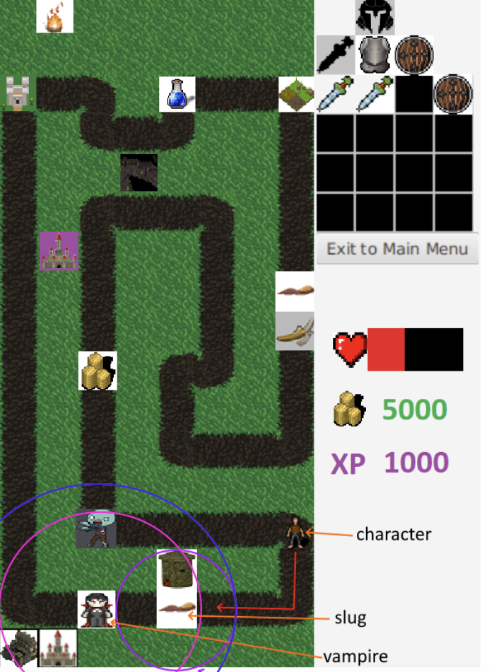

# Actions

|  |  |  |
| --- | --- | --- |
| Task | Allocation | Due date |
| Implement methods in the backend for buildings and cards | Suiyue Jiang | 10/7 Saturday |
| Implement methods in the backend for characters and menu | Weiqiang Zhuang | 10/7 Saturday |
| Implement methods in the backend for items and enemies | Wenyao Chen | 10/7 Saturday |
| Implement an MVP in the frontend | Ao Dong | 10/7 Saturday |